# Homework: Entity Framework

This document defines the homework assignments from the ["Database Applications" Course @ Software University](https://softuni.bg/trainings/21/Database-Applications-Mar-2015). Please submit as homework a single zip / rar / 7z archive holding the solutions (source code) of all below described problems.

## DbContext for the SoftUni Database

Your task is to create a DbContext for the **SoftUni** database (provided in the [course page](https://softuni.bg/trainings/1169/Database-Applications-Jul-2015)) using the Visual Studio Entity Data Model Wizard for **Database First**. Map all database tables. Exclude any stored procedures.

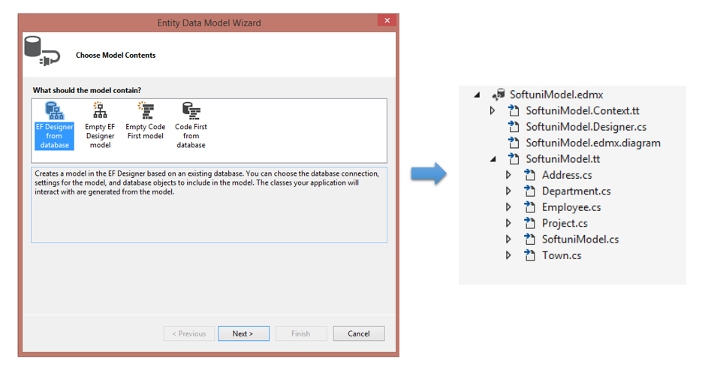

## Employee DAO Class

Your task is to create a Data Access Object (DAO) class with static methods, which provide functionality for **inserting**, **finding by key**, **modifying** and **deleting** employees.

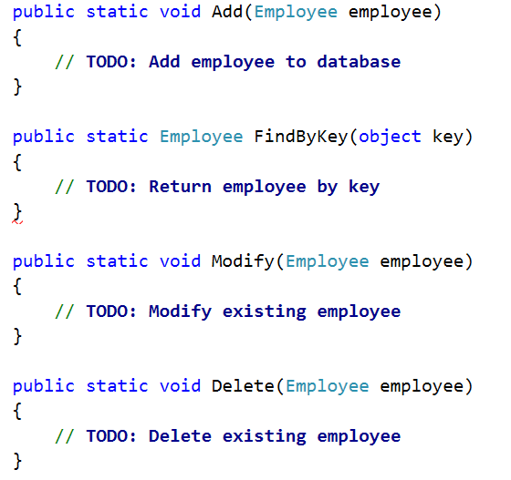

Write a testing class which:

1. Inserts an employee
2. Prints his/her primary key generated by the DB
3. Changes the employee first name and saves it to the database
4. Deletes an employee

## Database Search Queries

Writer the following queries in LINQ:

1. Find all employees who have **projects** started in the time period **2001 - 2003** (inclusive). Select each employee's **first name**, **last name** and **manager name** and each of their projects' **name**, **start date**, **end date**.
2. Find all addresses, **ordered** by the **number of employees** who live there (descending), then by **town name** (ascending). Take only the **first 10 addresses** and select their **address text**, **town name** and **employee count**.

|  |  |
| --- | --- |
| **Query Materialization** | **Query Result** |
|  |  |

1. Get an **employee by id** (e.g. 147). Select only his/her **first name**, **last name**, **job title** and **projects** (only their names). The projects should be **ordered** **by** **name** (ascending).
2. Find **all departments** with more than **5 employees**. Order them by **employee count** (ascending). Select the **department name**, **manager name** and first name, last name, hire date and job title of every **employee**.

|  |  |
| --- | --- |
| **Query Materialization** | **Query Result** |
|  |  |

Ensure that Entity Framework generates **only 1 SQL** **query** for each of the tasks by using **Express Profiler**.

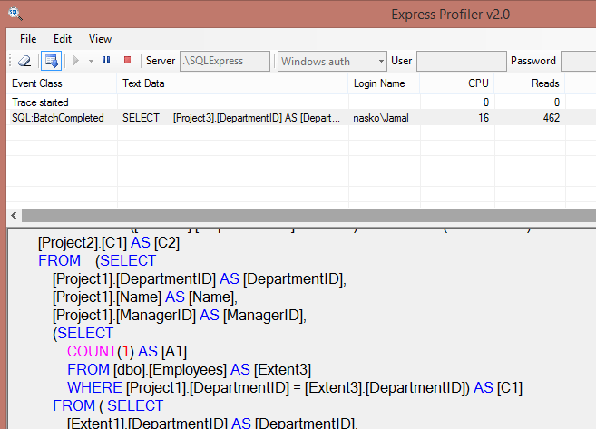

## Native SQL Query

Find all **employees** who have projects with **start date** in the year **2002**. Select only their **first name**. Solve this task by using both **LINQ query** and **native SQL query** through the context.

Measure the difference in performance in both cases with a **Stopwatch**. Comment out any printing so the measurements can be most accurate.

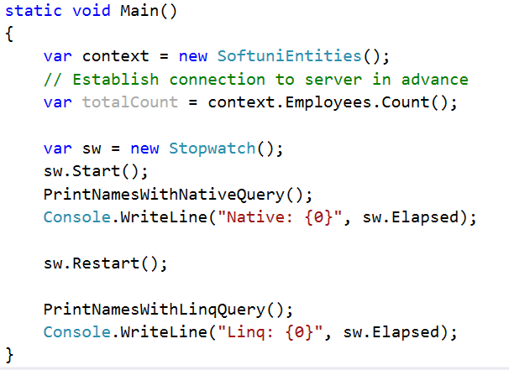

**Tip**: Use the **context.Database.SqlQuery<T>()** method for executing native SQL queries.

## Concurrent Database Changes with EF

Open two different data contexts and perform concurrent changes on the **same records** in some database table.

1. Open the first context and make changes to a column
2. Open the second context and make changes to a column
3. Consecutively call **SaveChanges()** on both contexts

What will happen at SaveChanges()?

Go to the **.edmx diagram editor** and set property **[Concurrency Mode]** of the column you are trying to modify to **Fixed**. Run the code again and see if there are any differences.

## Call a Stored Procedure

Your task is to create a stored procedure in the **SoftUni** database for finding **all projects** for given employee. The procedure should receive **first name** and **last name** as arguments.

Using EF implement a C# method that calls the stored procedure and returns the result projects' **name**, **description** and **start date**.

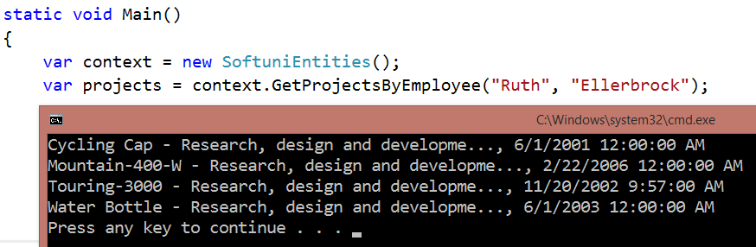

## * Play with the SQL Server Profiler

Your task is to use the [SQL Server ExpressProfiler](https://expressprofiler.codeplex.com/) to view all your queries from the previous homework task. Submit a screenshot as a homework.

## * Explore the Full Source Code of Entity Framework

Your task is to download (clone the repository) and explore the full source code of Entity Framework. You can find it on [http://entityframework.codeplex.com](http://entityframework.codeplex.com/). Do not submit anything for this problem.